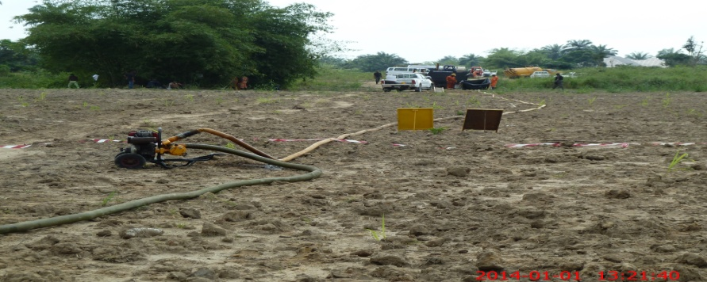
- Picture showing recovery host,
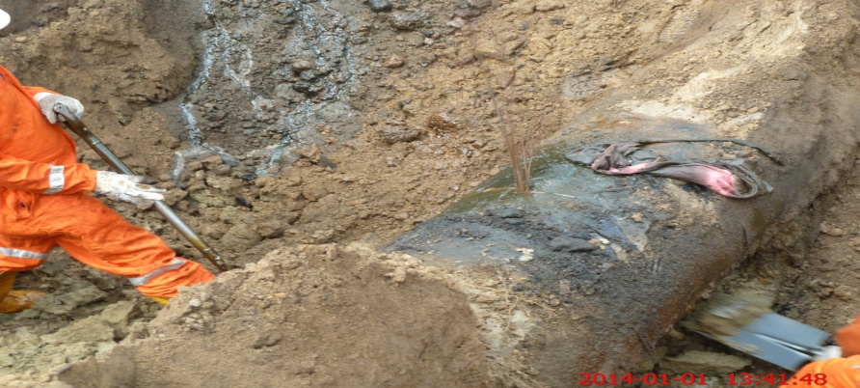
2.Picture showing hacksaw cut with crude spilling out.
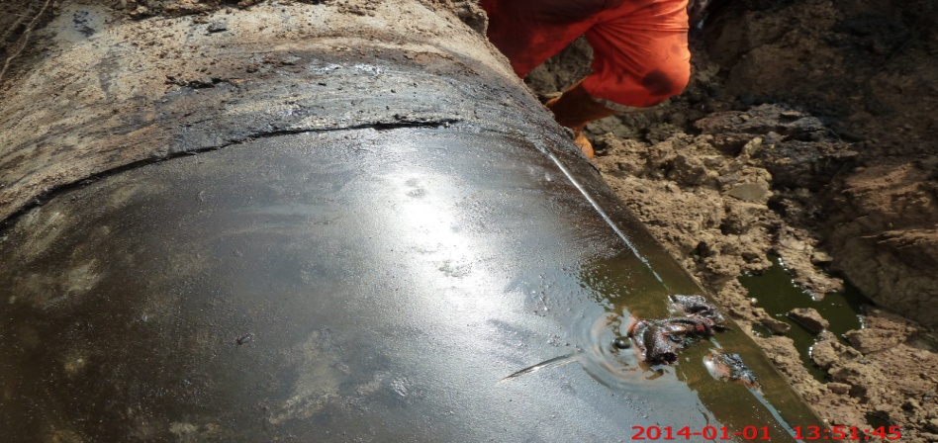
3.Showing spill point stopped ready for repair.
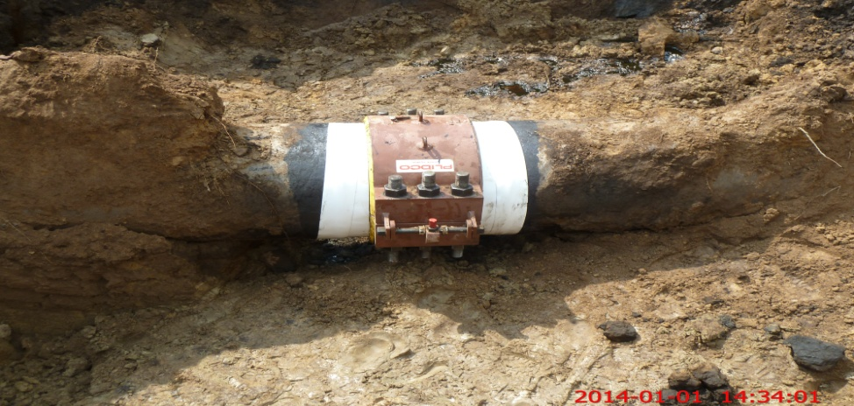
4. showing spill point clamped.

